**Muscles and Bones Workbook**

Teacher:

Student:

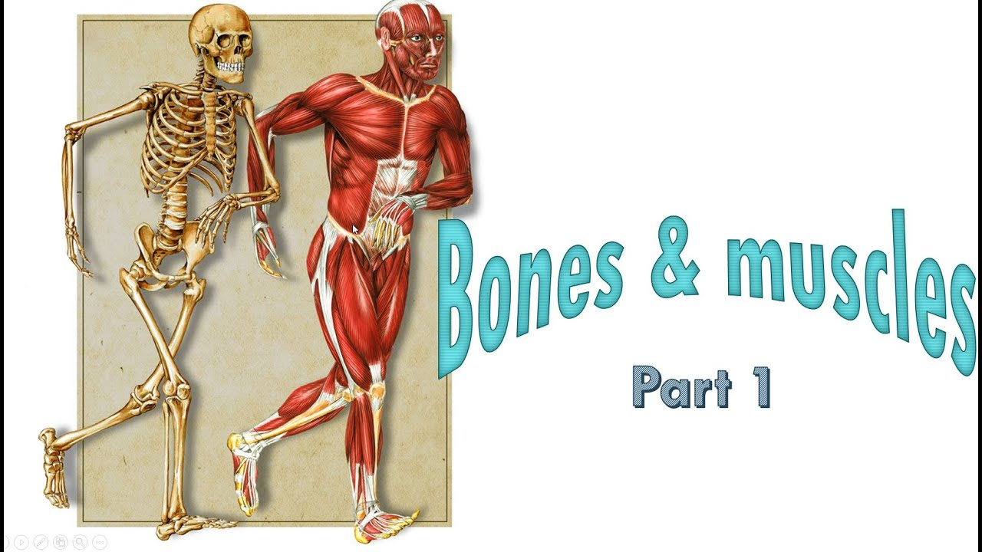

**Learning Intentions:**

* Identifying anatomical terminology
* Major bones of the body
* Structure and function of bones
* Major muscles of the body
* Structure and function of muscles
* Characteristics of skeletal muscle tissue
* Origin and insertion points
* Agonist and antagonist pairs

**Success Criteria:**

* Name and describe anatomical terms:
  + Flexion and extension
  + Abduction and adduction
  + Rotation
  + Circumduction
  + Pronation and supination
  + Dorsi flexion and plantar flexion
* Label all the major bones in the body:
  + Humerus, Radius, Ulna, Femur, Patella, Tibia, Fibula, Pelvis, Sternum, Ribs, Carpals, metacarpals, phalanges, tarsals, metatarsals
* Explain the 5 functions of the skeletal system
  + Framework, Attachment, Protection, Storing minerals, Red blood cells production
* Label all the major muscles in the body:
  + Sternomastoid, Trapezius, Latissimus Dorsi, Deltoid, Biceps, Triceps, Hand and finger flexors/extensors, Pectoralis, Abdominals, Intercostals, Gluteus Maximus, Hamstring group, Quadriceps group, Gastrocnemius, Tibialis Anterior

* Explain the 4 functions of the muscular system
  + Movement, Maintain posture, Maintain bodily functions, Generating heat
* Explain the 4 characteristics of muscle tissue
  + Excitability, Extensibility, Contractibility, Elasticity
* Define origin and insertion points and explain their importance in producing movement
* Define agonist and antagonist muscles and explain how they relax and contract to produce movement
* Identify various muscles, agonist pairs and anatomical movements across multiple sporting examples

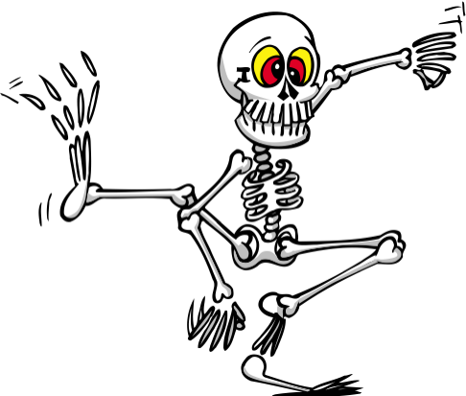Functional Anatomy

Bones, Bones, Bones

Functional anatomy is the study of the body parts required to complete a human movement or function.

The human skeleton is comprised of **206 bones!** The bones are held together by tough fibrous bands called **ligaments.**

There are five major functions of bones: In the space provided write a few brief sentences about each function and provide an example where possible.

* S _______________________________________________________

_______________________________________________________

_______________________________________________________

* P _______________________________________________________

_______________________________________________________

_______________________________________________________

* M _______________________________________________________

_______________________________________________________

_______________________________________________________

* S _______________________________________________________

_______________________________________________________

_______________________________________________________

* B cell production _______________________________________________________

_______________________________________________________

_______________________________________________________

Muscles

You have more than 600 muscles in your body. Some muscles help you move, lift, or sit still. Others help you digest food, breathe, or see. Your heart is a muscle that pumps blood through your body.

There are 4 major functions of muscles. In the space provided write a few brief sentences about each function and provide an example where possible.

* M _______________________________________________________

_______________________________________________________

_______________________________________________________

* P _______________________________________________________

_______________________________________________________

_______________________________________________________

* M _______________________________________________________

_______________________________________________________

_______________________________________________________

* G _______________________________________________________

_______________________________________________________

_______________________________________________________

Functional Anatomy

Practice!

Create a key and colour in the skeleton below.

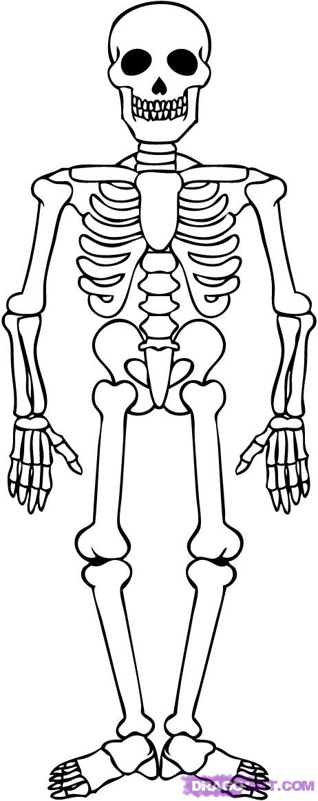

__________________

__________________

__________________

__________________

__________________

__________________

__________________

__________________

__________________

__________________

__________________

__________________

__________________

__________________

__________________

**Practice labelling all the major bones in the body using the word bank provided.**

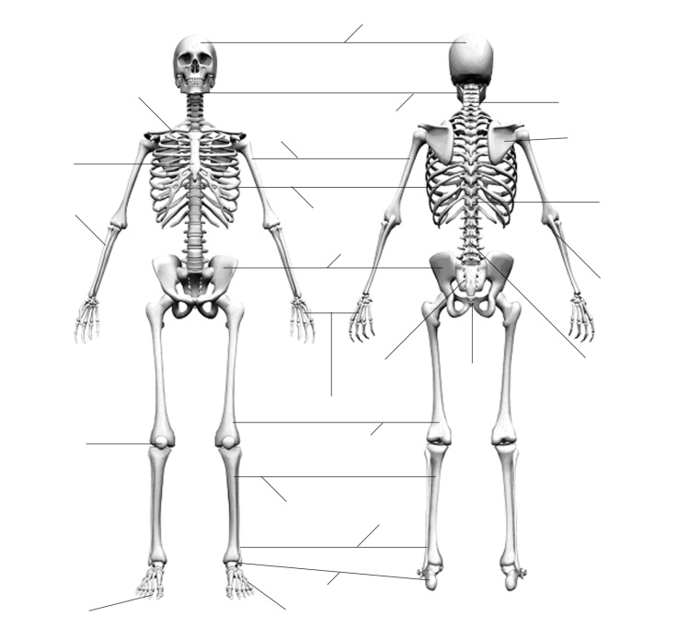

patella phalanges

cranium/skull mandible

pelvic girdle/pelvis scapula

thoracic vertebrae lumbar vertebrae

cervical vertebrae ribs

coccyx humerus

radius ulna

tarsals carpals

metatarsals metacarpals

fibula tibia

sacrum femur

clavicle

**Practice labelling all the major muscles in the body using the word bank provided.**

(NOTE: Some muscles are labelled twice):

triceps gastrocnemius sternomastoid

trapezius latissimus dorsi hand and finger flexors

abdominals hand and finger extensors deltoid

pectorials hamstring group quadriceps group

tibialis anterior intercostals biceps

gluteus maximus

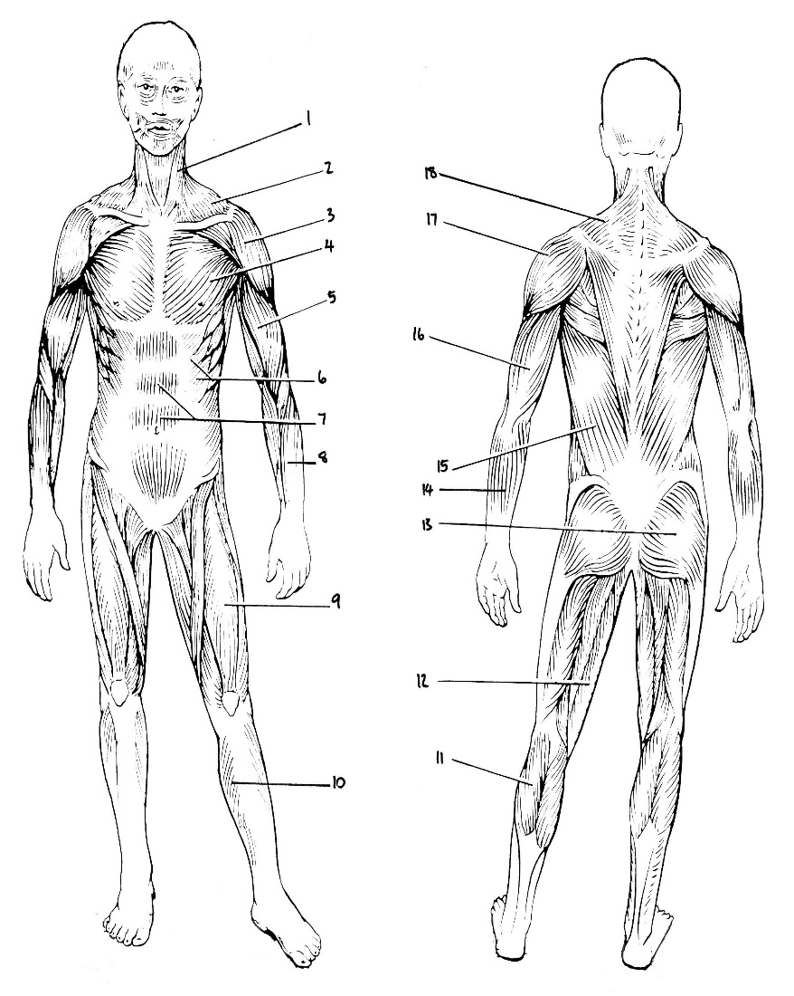

1.________________

2.________________

3. ________________

4. ________________

5. ________________

6. ________________

7. _________________

8. _________________

9. _________________

10. ________________

11. ________________

12. ________________

13. ________________

14. ________________

15. ________________

16. ________________

17. ________________

18. ________________

1. What is the correct name for the calf muscle?
   1. Calf
   2. Tibialis Anterior
   3. Achilles Tendon
   4. Gastrocnemius
2. The muscle group on the back, upper leg is:
   1. Deltoid
   2. Gluteal group
   3. Hamstrings
   4. Gastrocnemius

Functional Anatomy

Anatomical terms

**Name all the anatomical terms by placing the words into the correct boxes.**

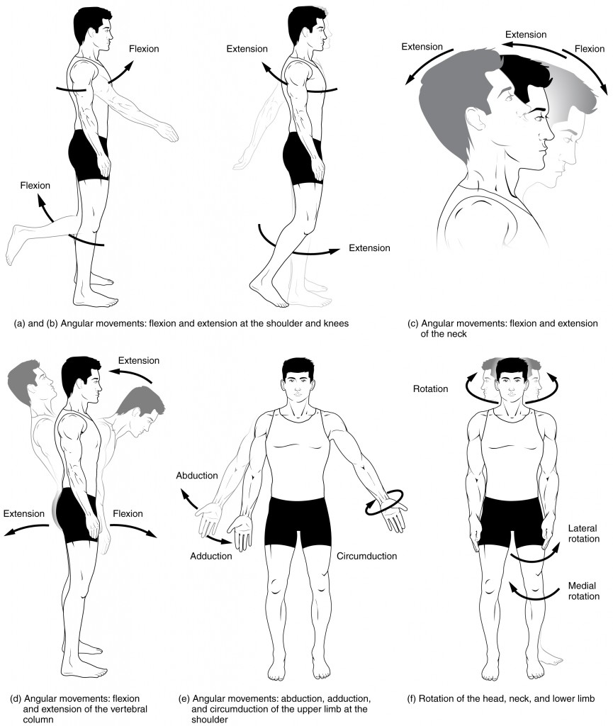

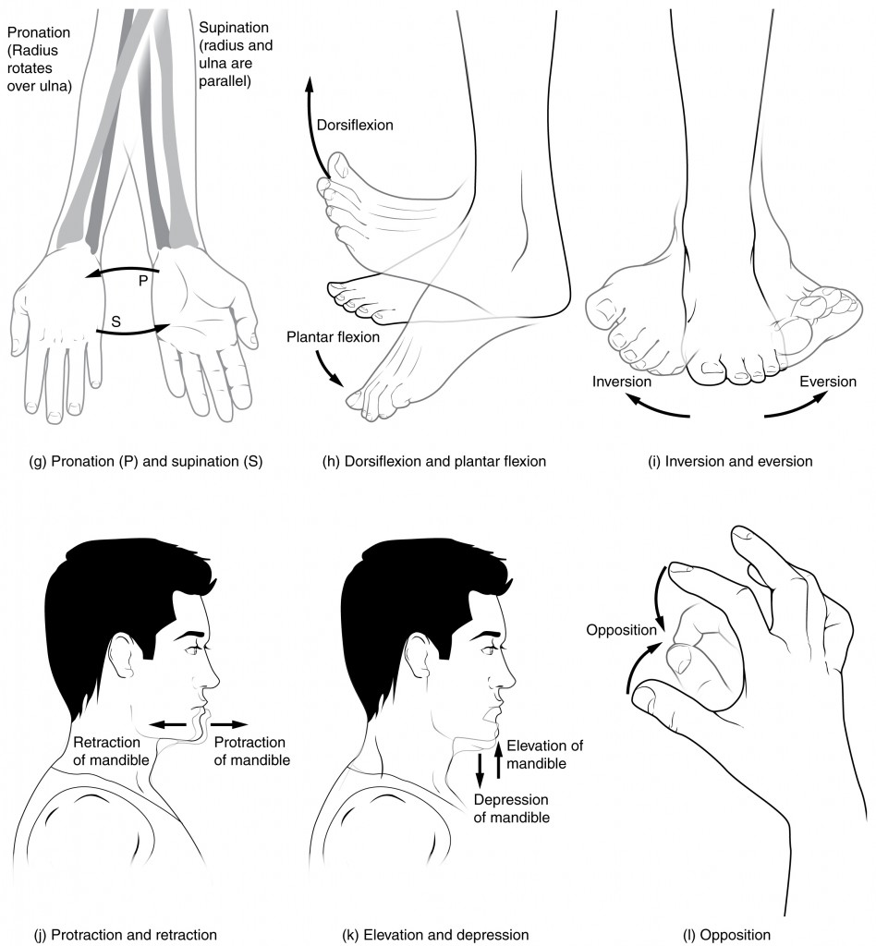

|  |  |
| --- | --- |
| **Movement** | **Definition** |
| **Flexion** |  |
| **Adduction** |  |
| **Supination** |  |
| **Plantarflexion** |  |
| **Depression** |  |
| **Circumduction** |  |
| **Inversion** |  |
| **Dorsiflexion** |  |
| **Horizontal abduction** |  |
| **Protraction** |  |
| **Opposition** |  |

Functional Anatomy

Anatomical terms

**Write a definition of all the anatomical movement terms, some of the terms might be unfamiliar, use a computer to find the answers.**

Functional Anatomy

Applying anatomical terms

**List all the anatomical movement terms in the pictures below. Be mindful to explain where the movement is occurring in the body. A hint has been provided for you.**

|  |  |
| --- | --- |
| https://upload.wikimedia.org/wikipedia/commons/thumb/8/82/Squats.svg/1280px-Squats.svg.png | Flexion of the elbow |
| Green Bay Packers QB Aaron Rodgers talks the art of the deep ball | Rotation of the neck |
| The Laws of Physics in Tennis - EE Times Europe |  |
| Pinch The Knee Pitching Drill - Baseball Tutorials |  |

Functional Anatomy

Short answer questions

**Question 1**

List 4 examples of extension in the body.

___________________________________________________________________

___________________________________________________________________

___________________________________________________________________

___________________________________________________________________

**Question 2**

List 3 examples of adduction in the body.

___________________________________________________________________

___________________________________________________________________

___________________________________________________________________

**Question 3**

Describe the action of flexion of the knee, with clear reference to the muscles involved in each of these actions.

___________________________________________________________________

___________________________________________________________________

___________________________________________________________________

**Question 4**

Muscles often work in pairs. Discuss what is meant by the agonist-antagonist relationship and use the hamstrings and quadriceps in your discussion to show applied understanding.

___________________________________________________________________

___________________________________________________________________

___________________________________________________________________

___________________________________________________________________

___________________________________________________________________

___________________________________________________________________

**Question 5**

Define the roles of agonist, antagonist, stabiliser and synergist muscles in the production of movement.

___________________________________________________________________

___________________________________________________________________

___________________________________________________________________

___________________________________________________________________

___________________________________________________________________

**Question 6**

Explain the role of origin and insertion points on producing movement.

___________________________________________________________________

___________________________________________________________________

___________________________________________________________________

___________________________________________________________________

___________________________________________________________________

___________________________________________________________________

___________________________________________________________________

**Question 7**

Select a skill movement sequence. Determine each of the discrete movements required to complete the skill successfully (E.g., Volleyball serve, extension of the arm)

___________________________________________________________________

___________________________________________________________________

___________________________________________________________________

___________________________________________________________________

___________________________________________________________________

**Question 8**

Describe the term reciprocal inhibition. Explain why it is important, using a sporting example to support your answer.

___________________________________________________________________

___________________________________________________________________

___________________________________________________________________

___________________________________________________________________

___________________________________________________________________

**Question 9**

Explain the 4 characteristics/properties of skeletal muscle tissue.

___________________________________________________________________

___________________________________________________________________

___________________________________________________________________

___________________________________________________________________

___________________________________________________________________

___________________________________________________________________

___________________________________________________________________

**Question 10**

1. Choose any 3 bones that allow us to walk. Label the bones in the diagram below.
2. Name one muscle that is attached to each of the bones you have chosen.

___________________________________________________________________

___________________________________________________________________

___________________________________________________________________

1. List the antagonists of the muscles you have chosen your response above.

___________________________________________________________________

___________________________________________________________________

___________________________________________________________________

1. List the type of joint action the agonist pair produce.

___________________________________________________________________

___________________________________________________________________

___________________________________________________________________

